**Assignment-5.**

**Program – 1**

**Write a program to enter P,T (principal and time) and calculate simple interest. Use the Scanner class for taking inputs from the console. Users will enter the principal amount and time(in years). Create an if-else statement and modify the interest rate based on the principal amount. If the amount > 10000 then the interest rate is 10%. If the amount is between 10000 and 5000 then make the interest rate 8%. For any amount below 5000 the interest rate should be 5%.**

import java.util.Scanner;

public class SimpleInterestCalculator

{

public static void main(String[] args)

{

Scanner sc = new Scanner(System.in);

// Taking inputs

System.out.print("Enter the principal amount: ");

double principal = sc.nextDouble();

System.out.print("Enter the time (in years): ");

double time = sc.nextDouble();

double rate;

// Deciding interest rate using if-else

if (principal > 10000)

{

rate = 10.0;

}

else if (principal >= 5000)

{

rate = 8.0;

}

else

{

rate = 5.0;

}

// Calculating Simple Interest

double simpleInterest = (principal * rate * time) / 100;

// Output

System.out.println("\n***** Simple Interest Details *****");

System.out.println("Principal: " + principal);

System.out.println("Time (Years): " + time);

System.out.println("Rate of Interest: " + rate + "%");

System.out.println("Simple Interest: " + simpleInterest);

sc.close();

}

}

**Output**

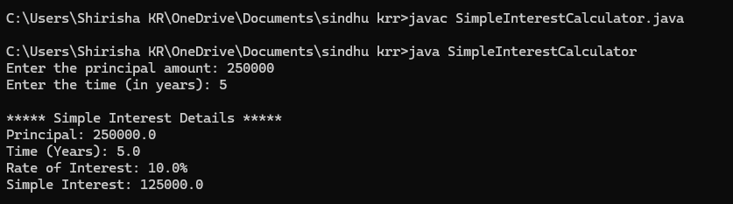

**Program – 2**

**Write a program to enter marks of five subjects and calculate total marks and average. Each subject has a full mark of 100. Give grades based on average marks. Grades should be Ex (>90%), A (>80%) , B(>60%) ,C (>=40%) and F(<40%).Use the Scanner class to take input from the console**

import java.util.Scanner;

public class GradeCalculator

{

public static void main(String[] args)

{

Scanner sc = new Scanner(System.in);

double totalMarks = 0;

int subjects = 5;

// Taking marks for 5 subjects

for (int i = 1; i <= subjects; i++)

{

System.out.print("Enter marks for subject " + i + " (out of 100): ");

double marks = sc.nextDouble();

// Validate input

if (marks < 0 || marks > 100)

{

System.out.println("Invalid marks entered. Please enter between 0 and 100.");

i--; // re-ask for the same subject

continue;

}

totalMarks += marks;

}

// Calculate average

double average = totalMarks / subjects;

// Determine grade

String grade;

if (average > 90)

{

grade = "Ex";

}

else if (average > 80)

{

grade = "A";

}

else if (average > 60)

{

grade = "B";

}

else if (average >= 40)

{

grade = "C";

}

else

{

grade = "F";

}

// Display results

System.out.println("\n--- Result ---");

System.out.println("Total Marks: " + totalMarks + " / 500");

System.out.println("Average: " + average + "%");

System.out.println("Grade: " + grade);

sc.close();

}

}

**Output**

